

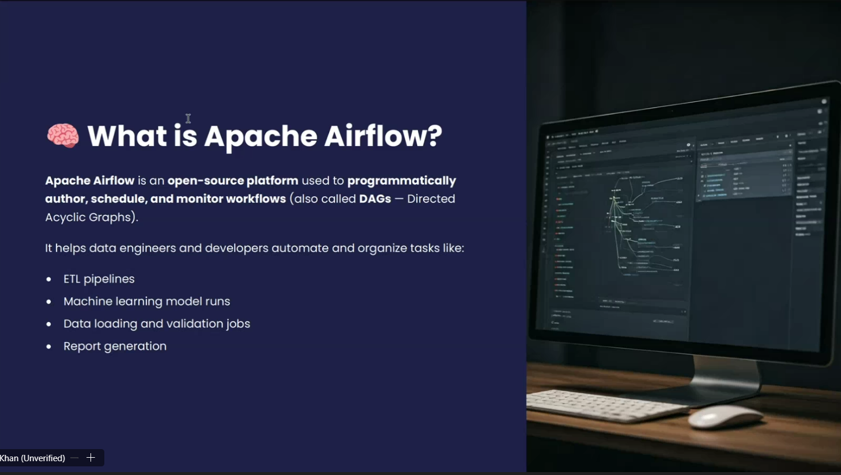

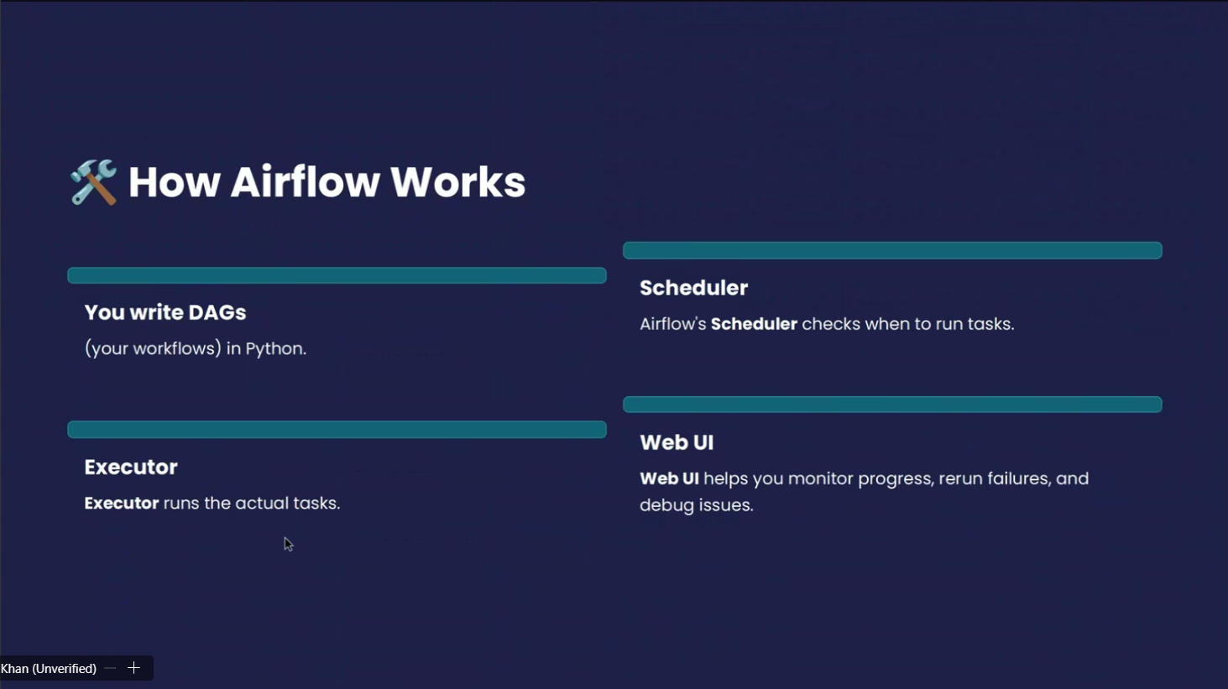
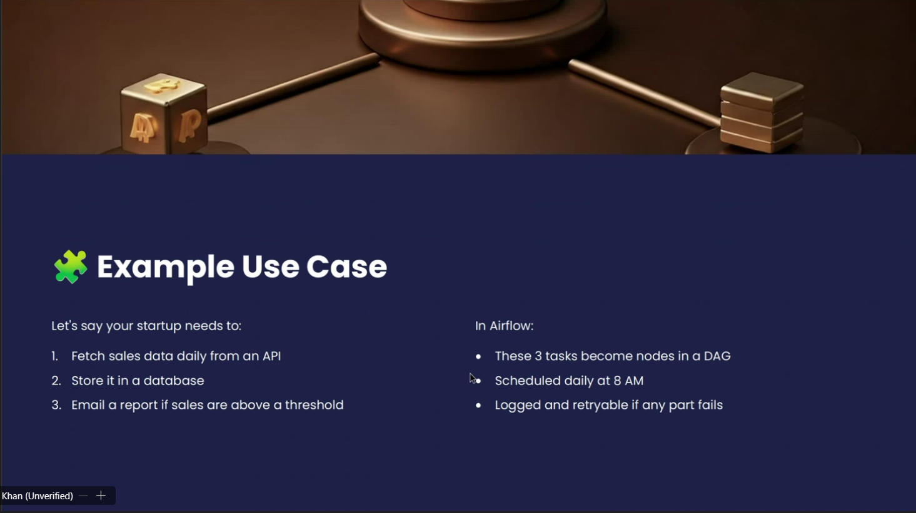
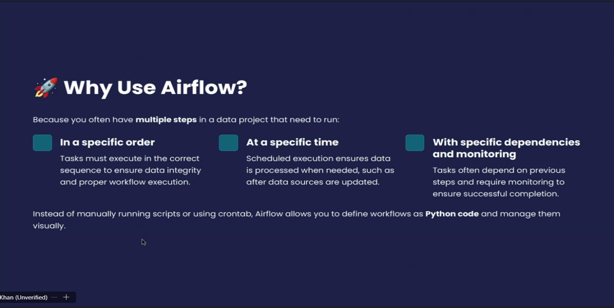

Apache Airflow:
Apache Airflow is an open-source workflow orchestration tool used to schedule, monitor, and manage data pipelines.
- Workflow orchestration → means arranging tasks (like extracting data, transforming it, loading into a database, training a model, etc.) in the correct order and making sure they run automatically.

Key Points about Airflow:
- Created by Airbnb, now part of the Apache Software Foundation.
- Uses DAGs (Directed Acyclic Graphs) → a set of tasks with dependencies showing the order of execution.
- Python-based → Workflows are written in Python scripts.
- Provides a web UI to track jobs, see logs, retry failed tasks, and monitor progress.
- Integrates with many systems (databases, cloud storage, Hadoop, Spark, etc.).
- Commonly used in ETL pipelines, data engineering, machine learning workflows, and DevOps automation.

Example: If you want to
- Extract sales data from an API,
- Transform it using Python,
- Load it into a database,
- Then send a report email
Airflow can schedule and automate all these steps daily, and if one step fails, it can retry or alert you.

